数据分析
secret_1
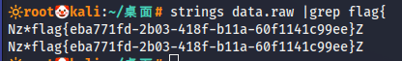
flag{eba771fd-2b03-418f-b11a-60f1141c99ee}

